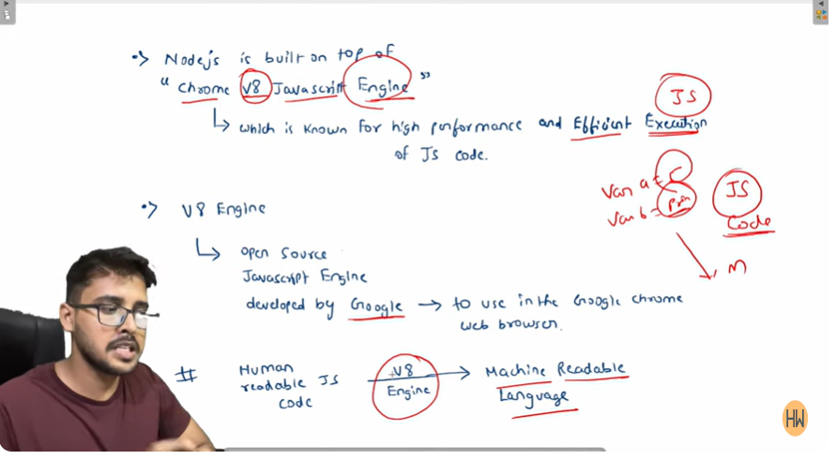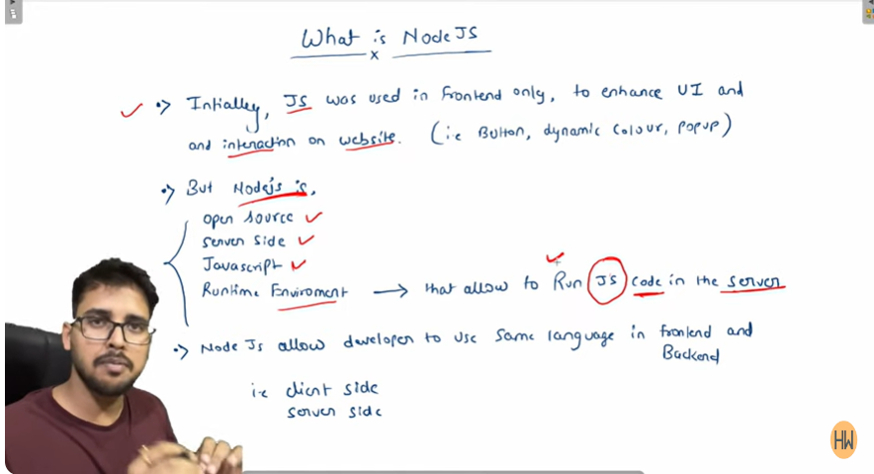**Lecture-1 Introduction to Node.js and Basics of Javascript**

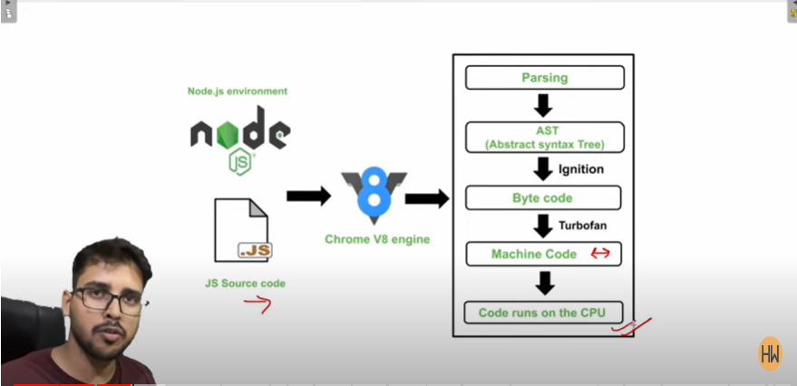

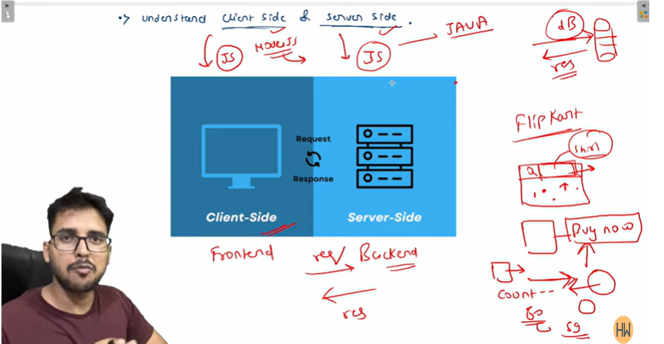

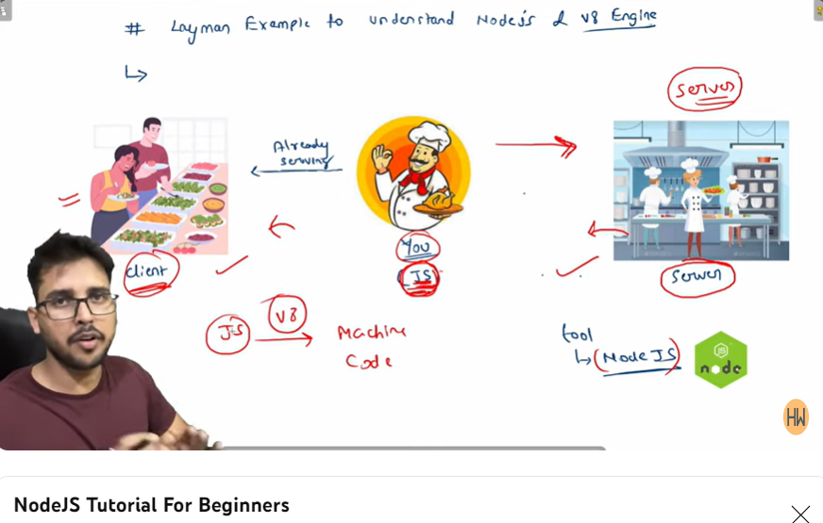

**INSTALL**

**Node,postman**

**npm -v version check**

**npm -v for version check**

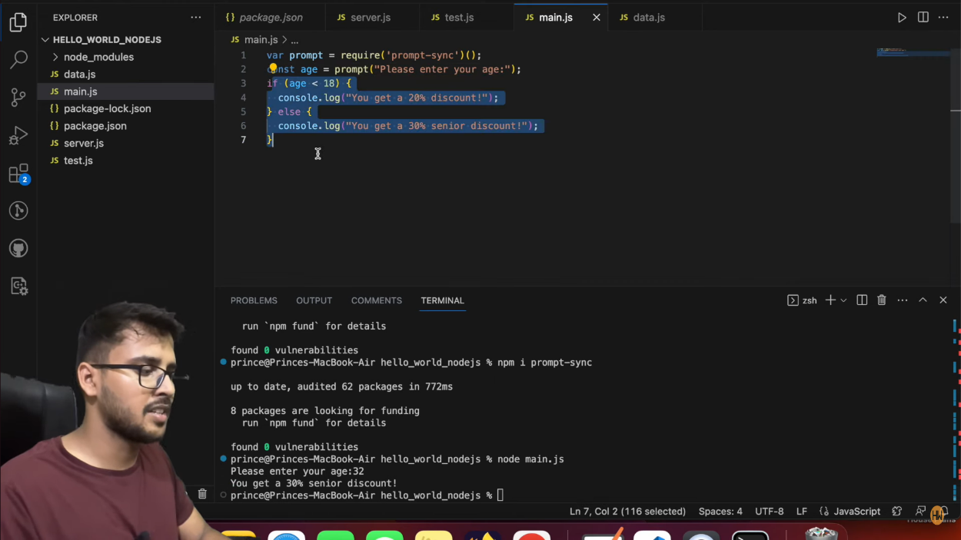

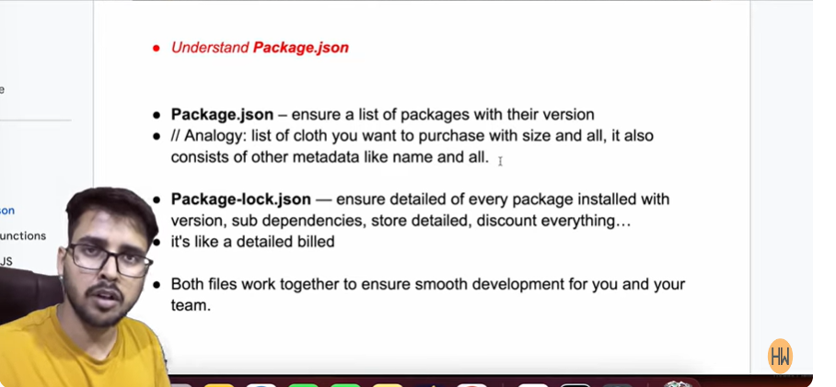**Lecture-2 Create Server in Nodejs**

For clearing logs… clear command

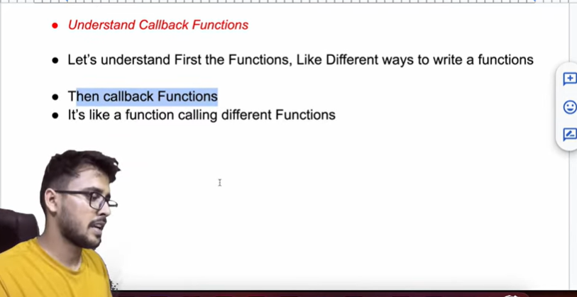If nodemon didn’t work for you so instead of installing it globally use this command🡪 npx nodemon server.js

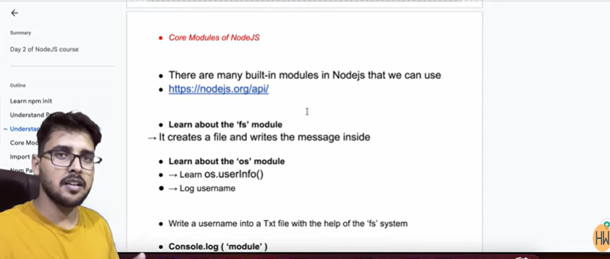

File.appendFile(filePathname, data, callback)

For using fs and os we firstly need to require them.

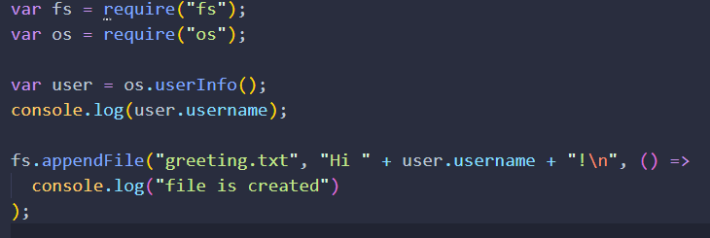

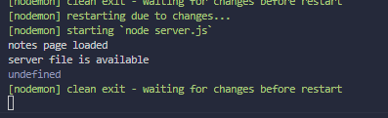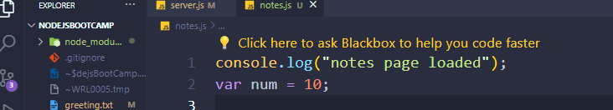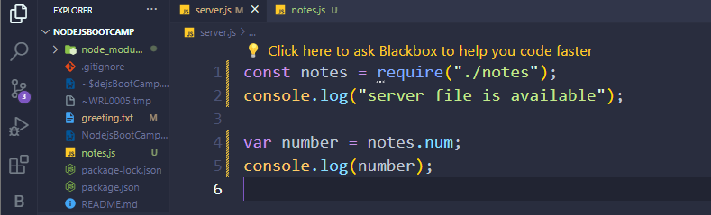

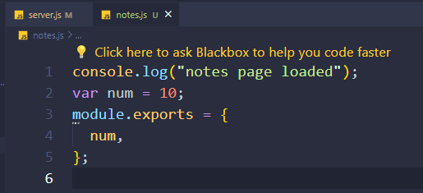It is showing undefined because I have to export it in-order to use it.

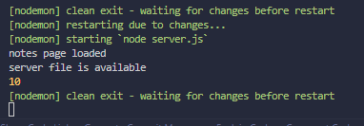

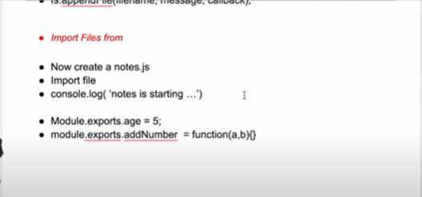

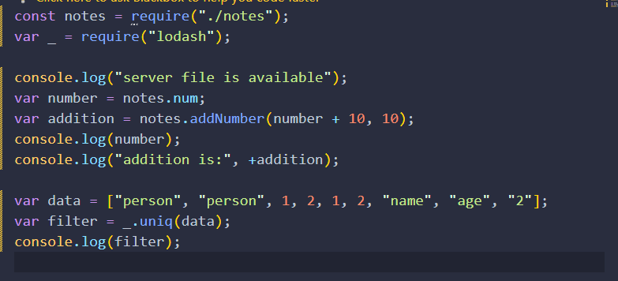**npm i lodash**

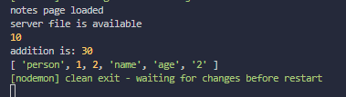

Lodash helps in our development and make it easy

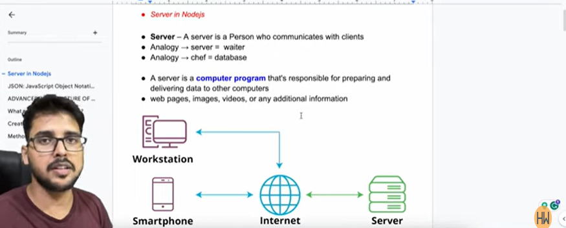**Lecture-3 Express js and REST API**

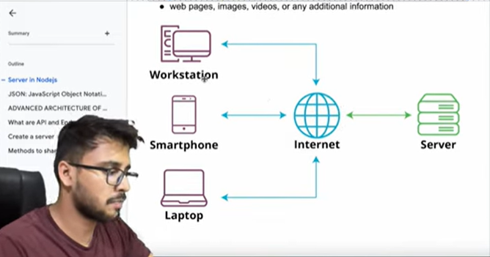

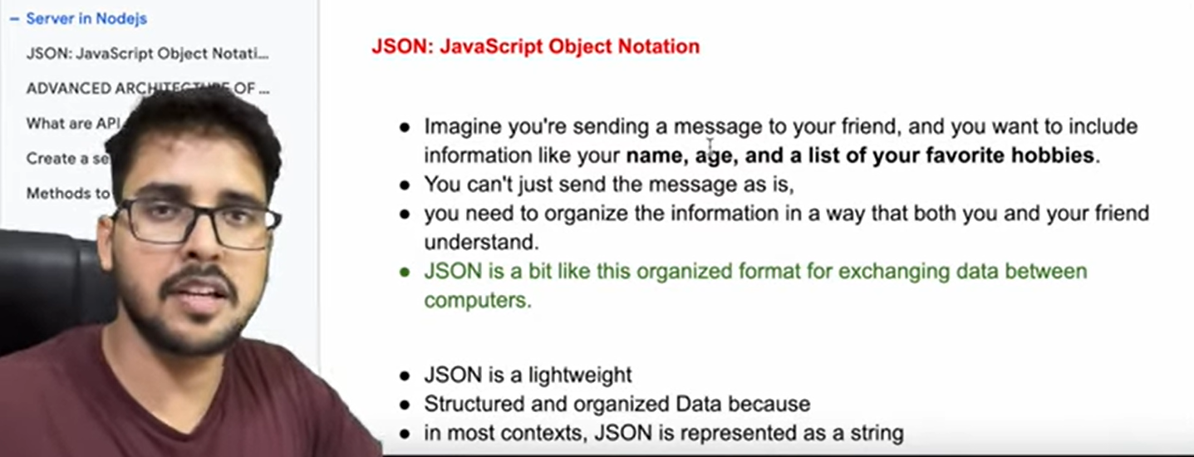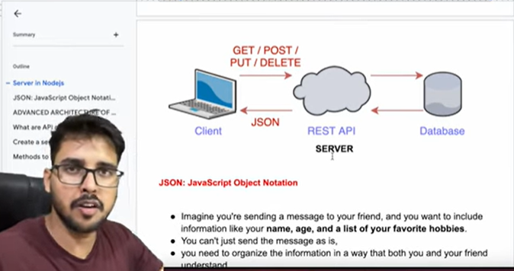

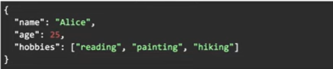

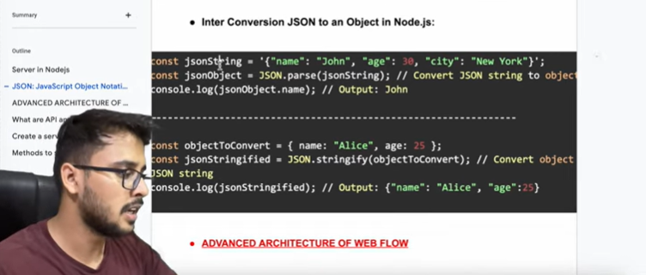

To run your file.

node server.js but here you need to run everytime the server.

nodemon server.js here no need to restart the server.

If nodemon doesn’t work write this then🡪

npx nodemon server.js

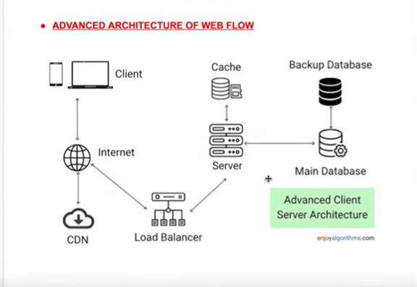

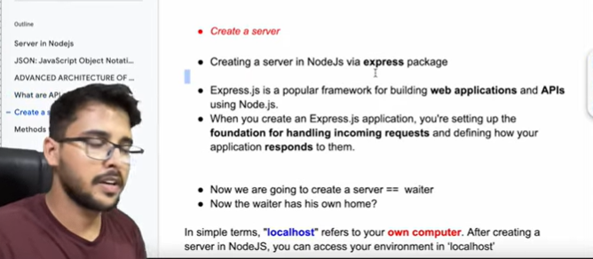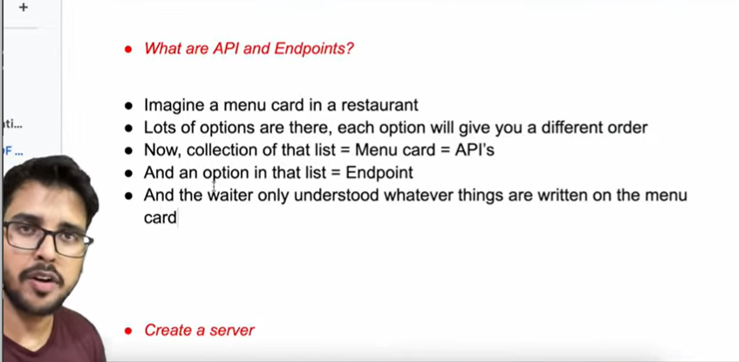

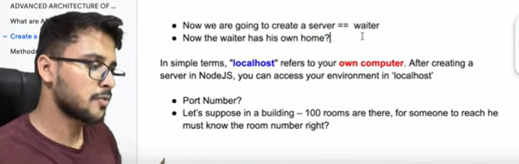

Port Number is basically the room no. of the waiter and local host is the hotel/building where our waiter live.

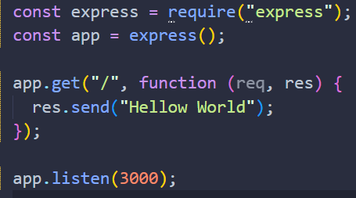

PORT NO: 3000

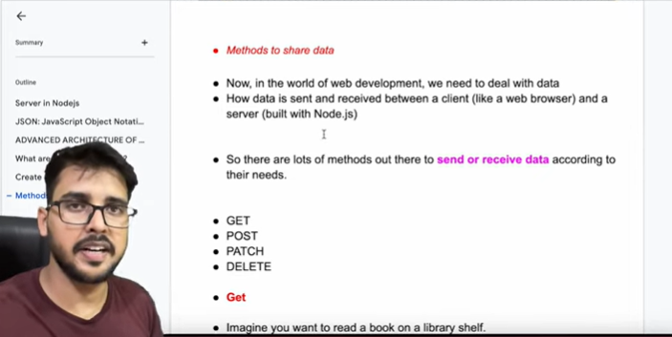

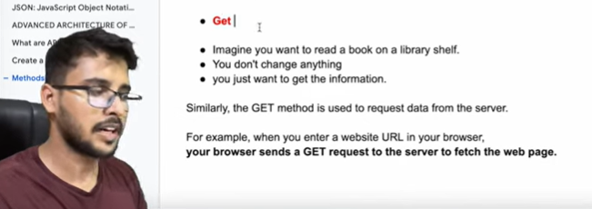

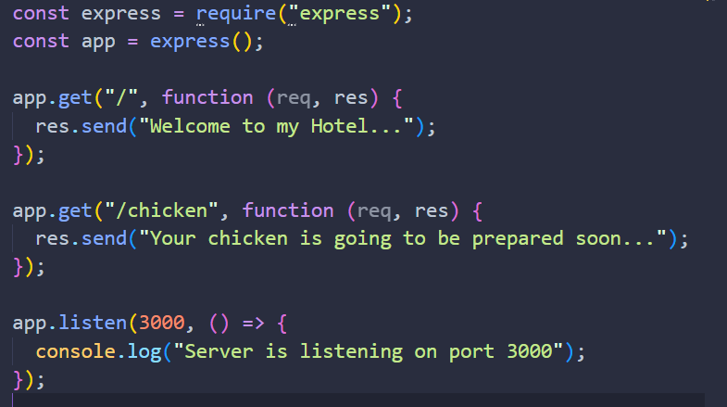

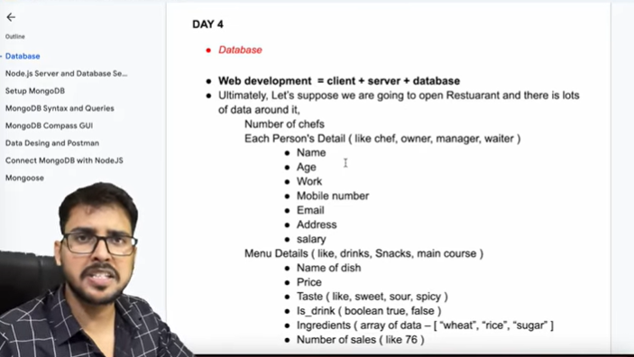**Lecture-4 MongoDB Tutorial**

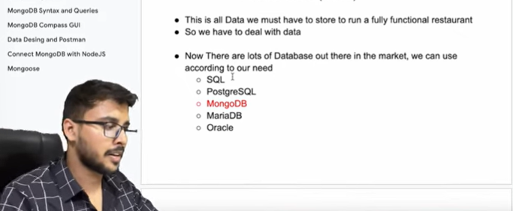

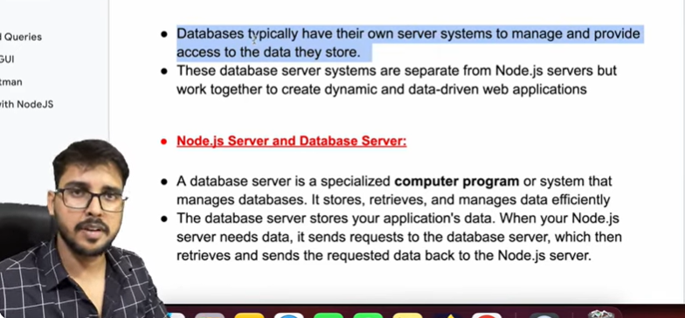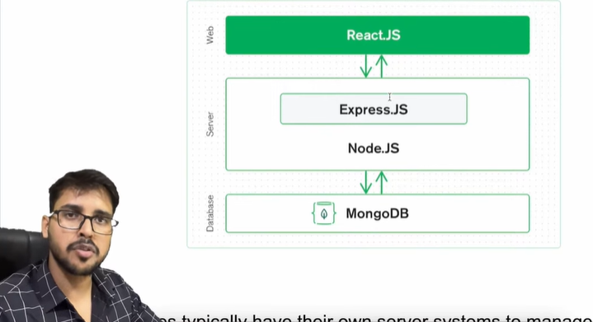

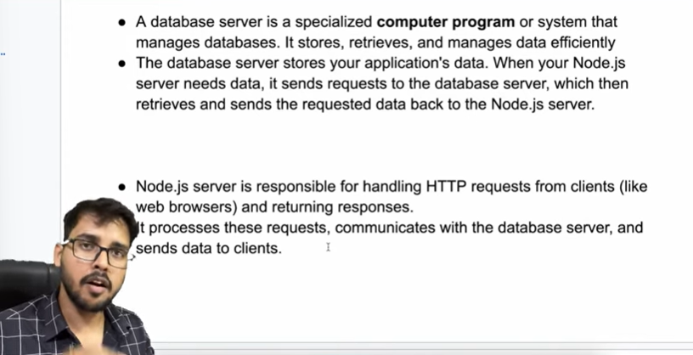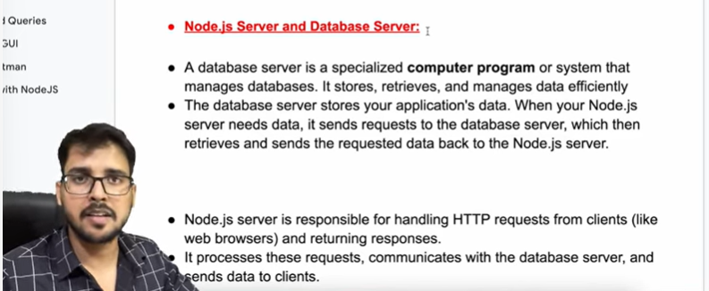

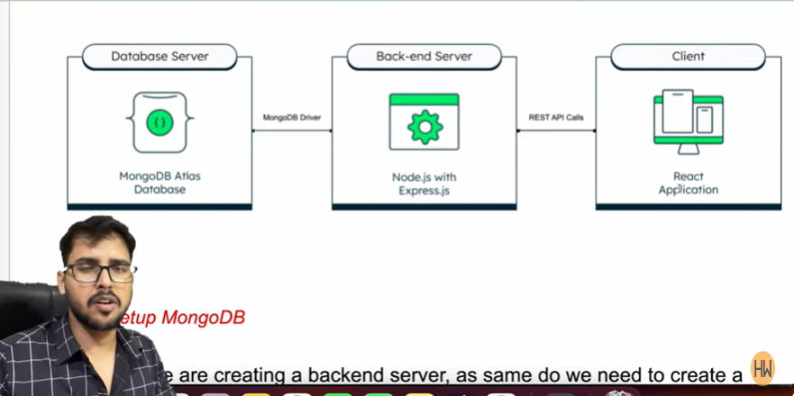

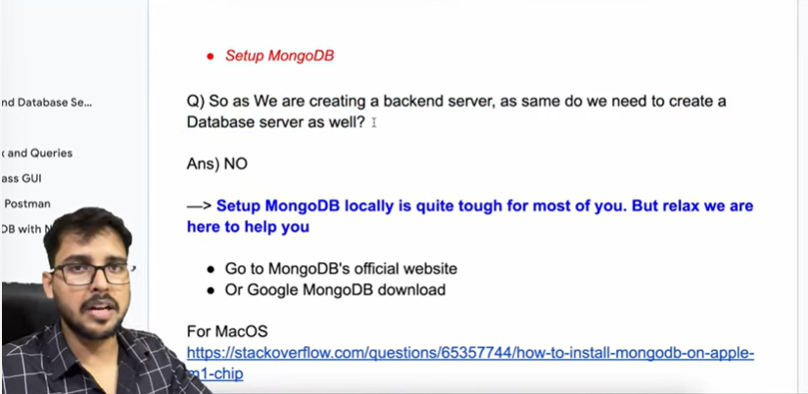

Firstly download MongoDB from MongoDB community then also download MongoDB Shell. Now cut and paste MongoDB shell folder in MongoDB folder which you will see in C program file then mongodb. After that open your environment variable then click on system path edit and paste this path of mongoosh which can be found in mongoShell folder.

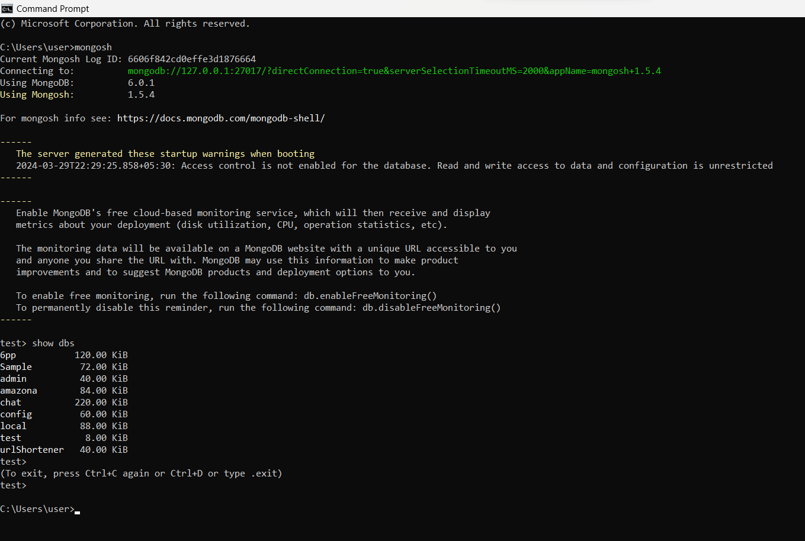Link:- [SetUp](https://youtu.be/gB6WLkSrtJk?si=z-yjkai6Rgsm0_x8)

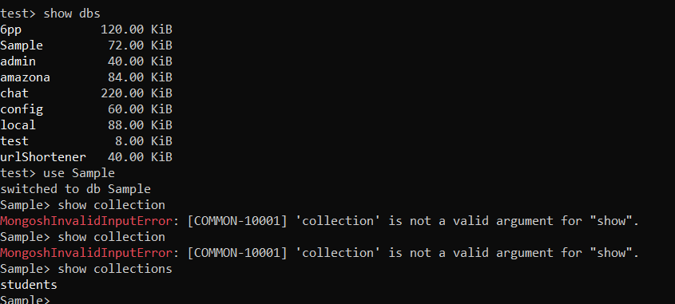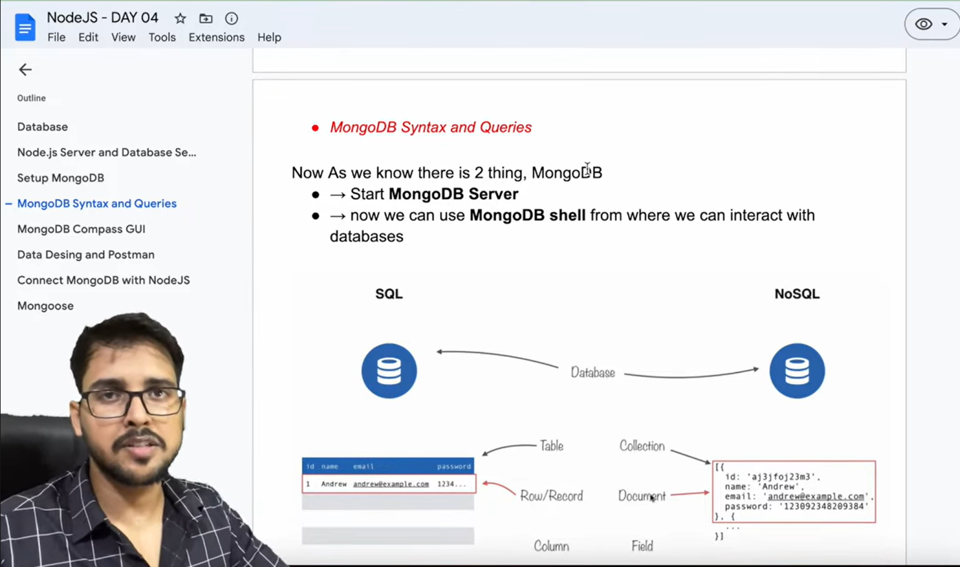

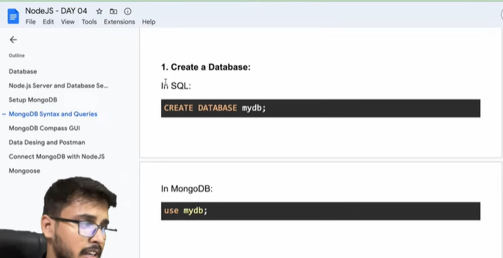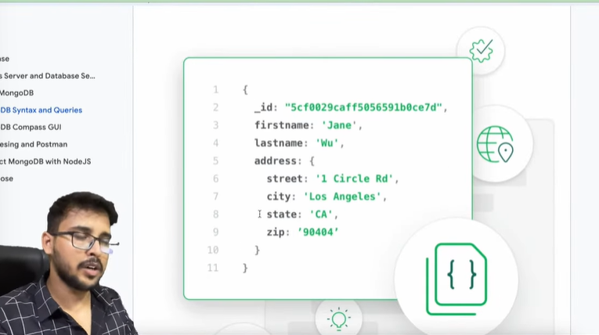

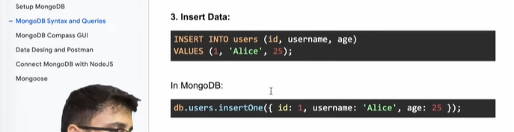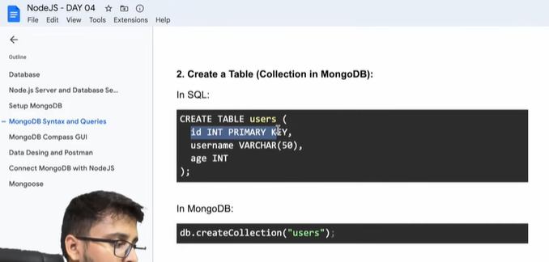

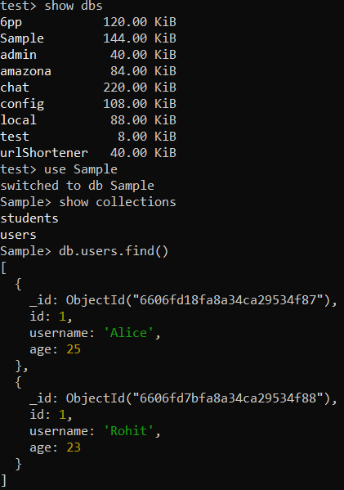

For seeing records in collections/tables

db.users.find()

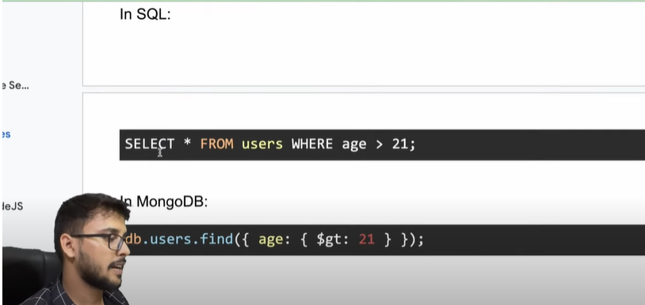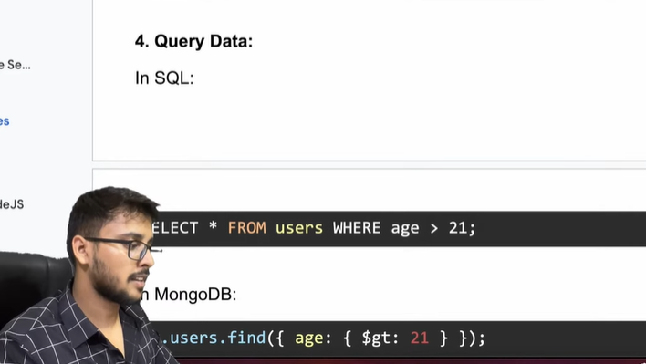

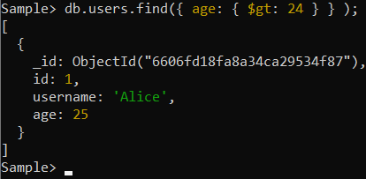

gt means greater than lt means less than

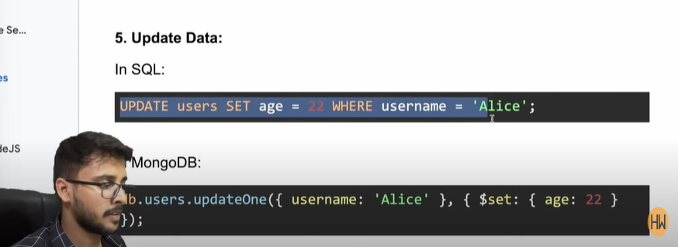

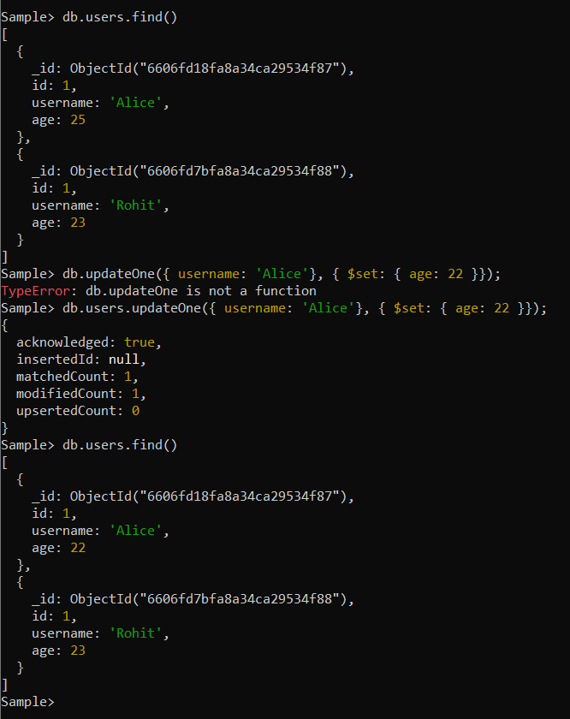

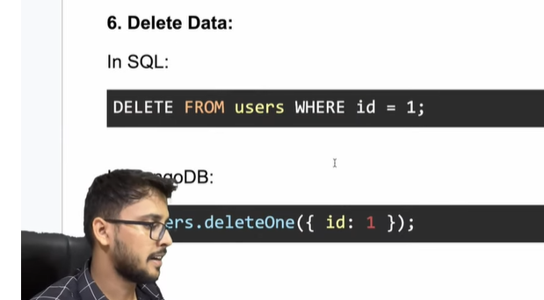

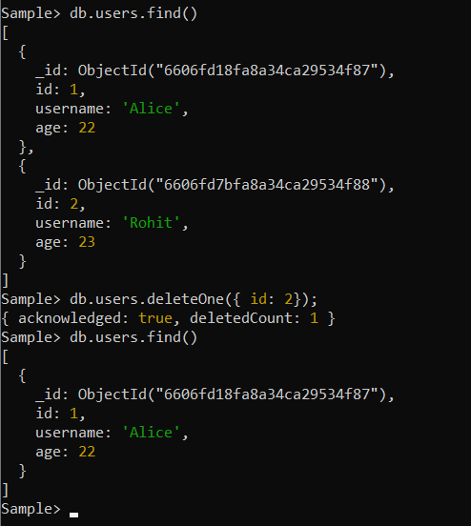

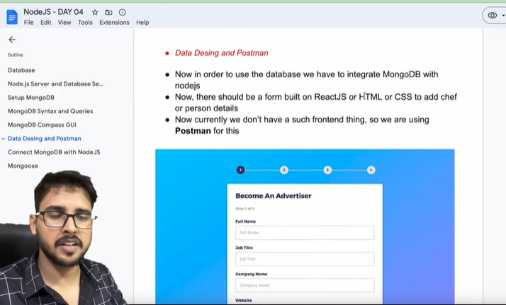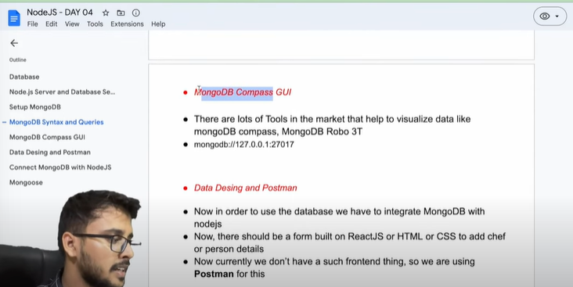

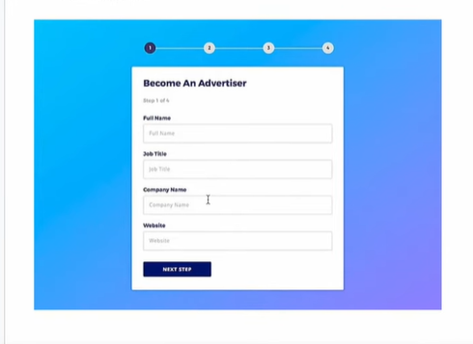

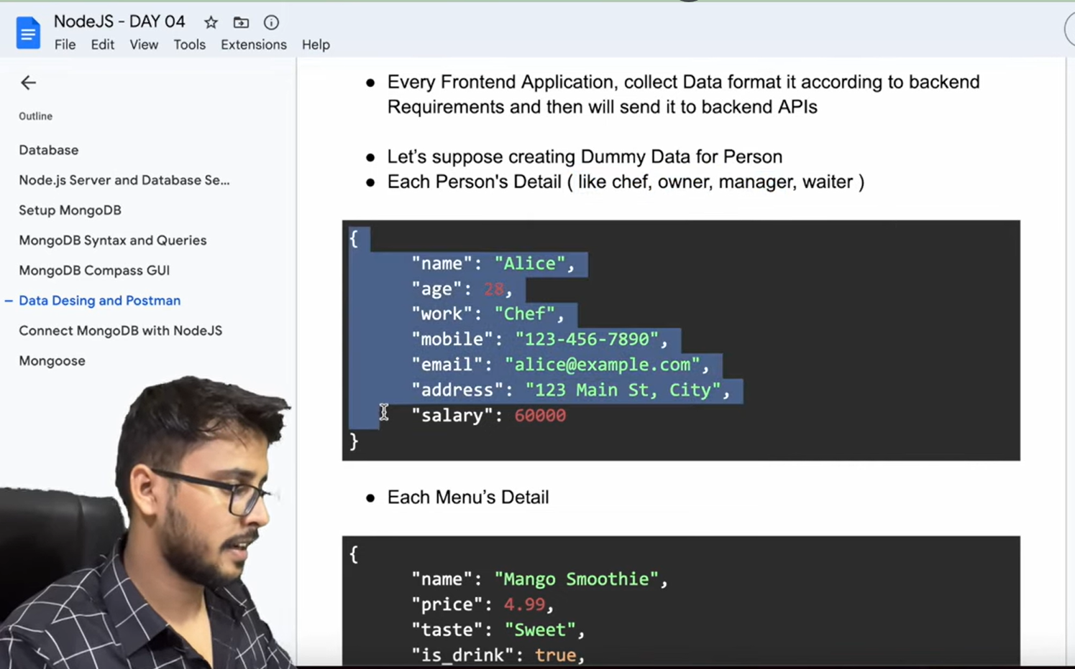

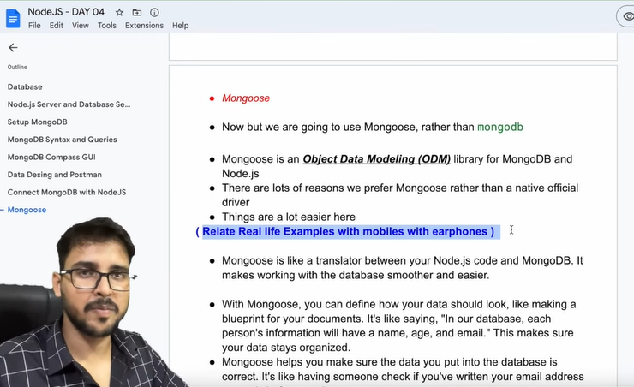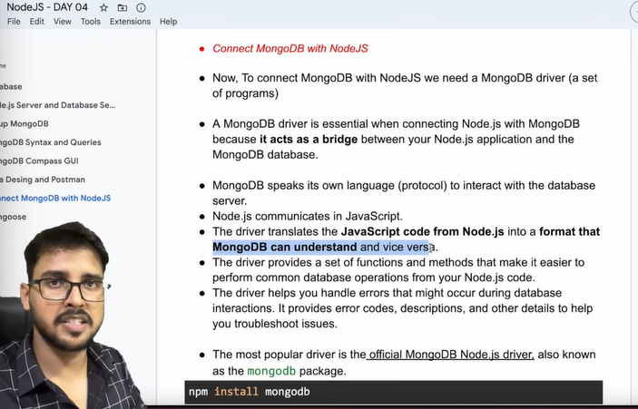

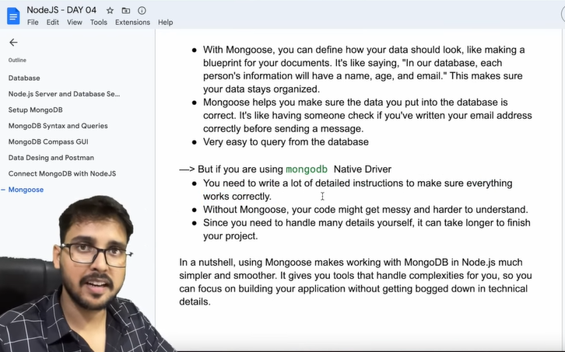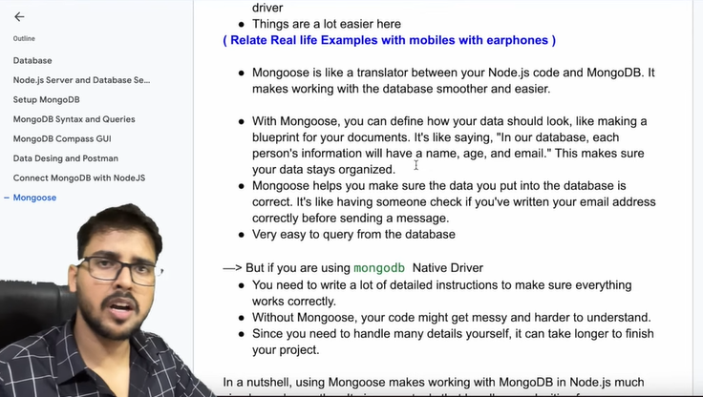

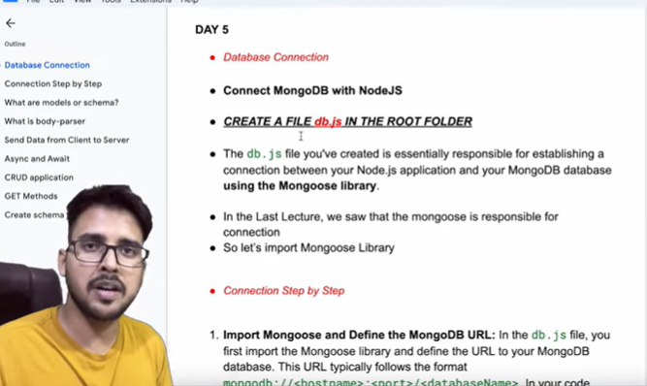**Lecture-5 Mongoose schema in Nodejs and CURD operation in Nodejs with try catch statement.**

npm i mongoose

"dependencies": {

    "express": "^4.19.2",

    "lodash": "^4.17.21",

    "mongoose": "^8.2.4",

    "nodemon": "^3.1.0",

    "prompt-sync": "^4.2.0"

  }

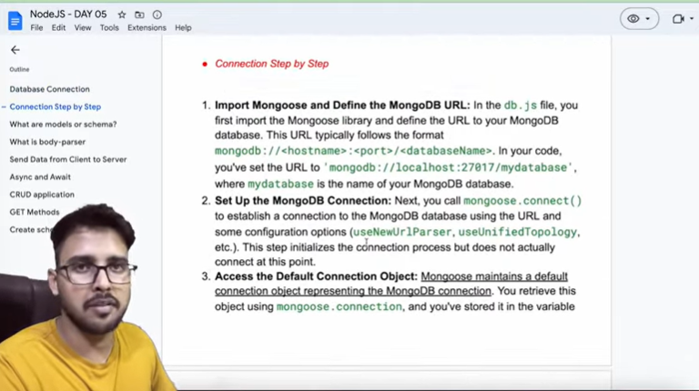

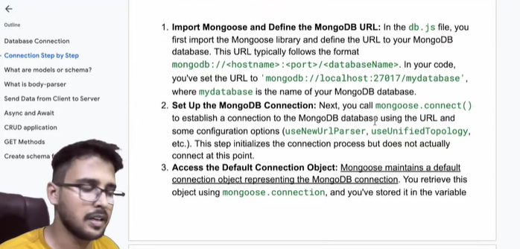

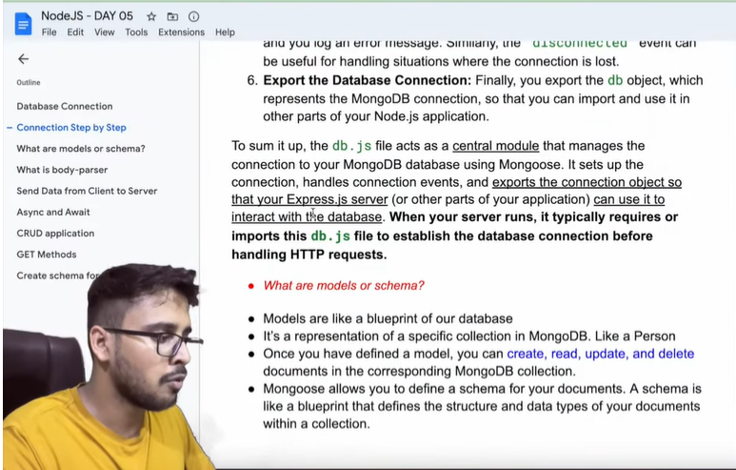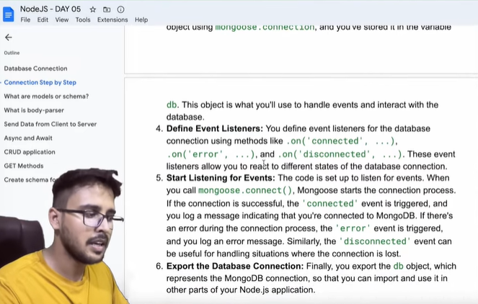

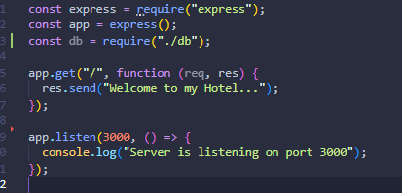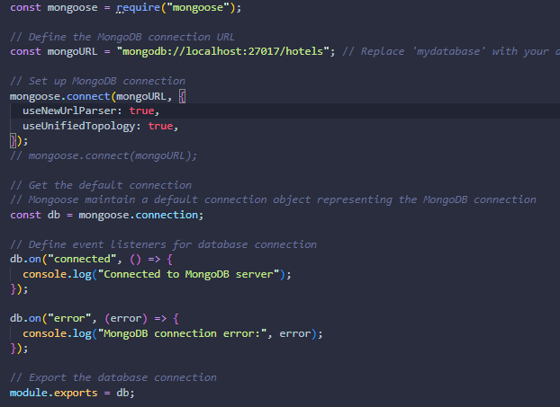

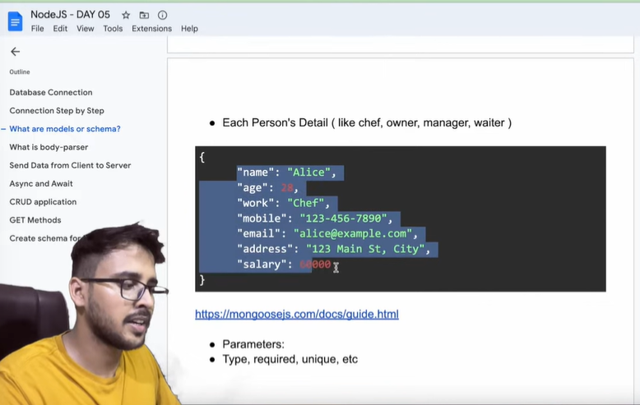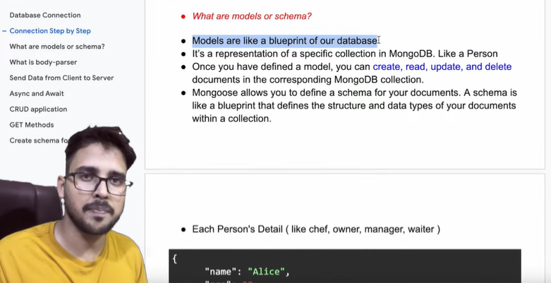

Schema is defined in a file which is in the models folder.

const mongoose = require("mongoose");

// *Define the Person Schema*

const personSchema = new mongoose.Schema({

  name: {

    type: String,

    required: true,

  },

  age: {

    type: Number,

  },

  work: {

    type: String,

    enum: ["chef", "waiter", "manager"],

    required: true,

  },

  mobile: {

    type: String,

    required: true,

  },

  email: {

    type: String,

    required: true,

    unique: true,

  },

  address: {

    type: String,

  },

  salary: {

    type: Number,

    required: true,

  },

});

// *Create Person model*

const Person = mongoose.model("Person", personSchema);

module.exports = Person;

const express = require("express");

const app = express();

const db = require("./db");

const Person = require("./models/Person");

app.get("/", function (req, res) {

  res.send("Welcome to my Hotel...");

});

app.listen(3000, () => {

  console.log("Server is listening on port 3000");

});

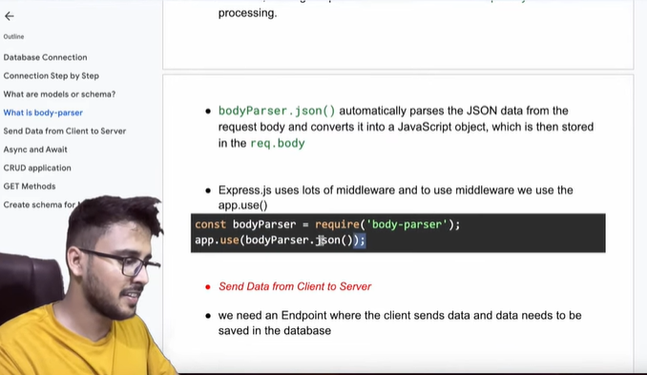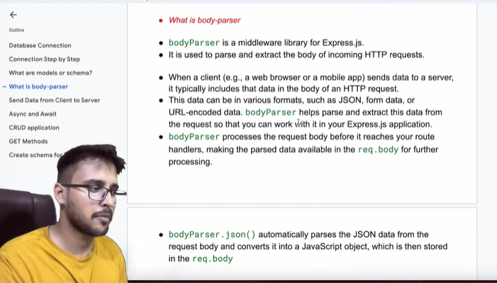

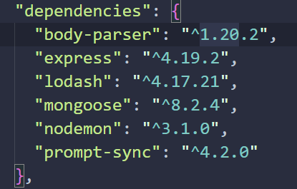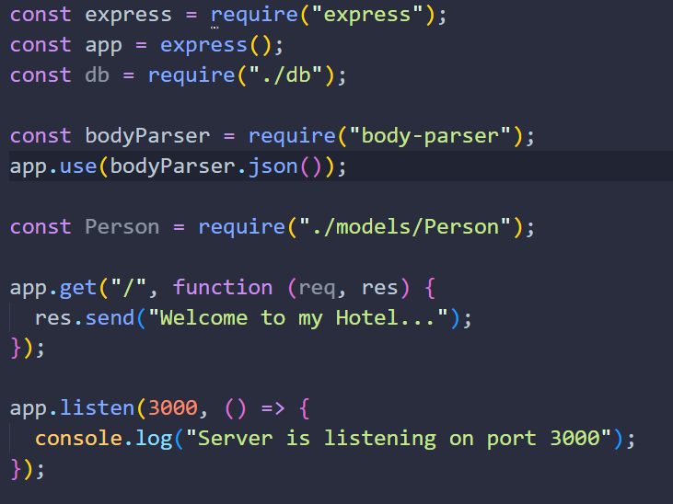npm i body-parser need to be installed.

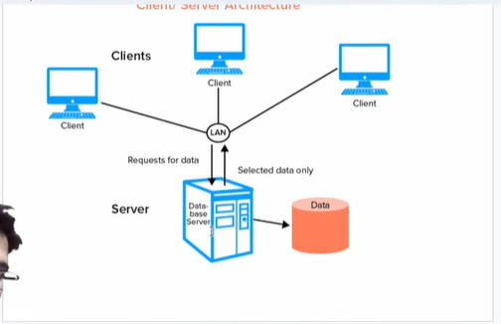

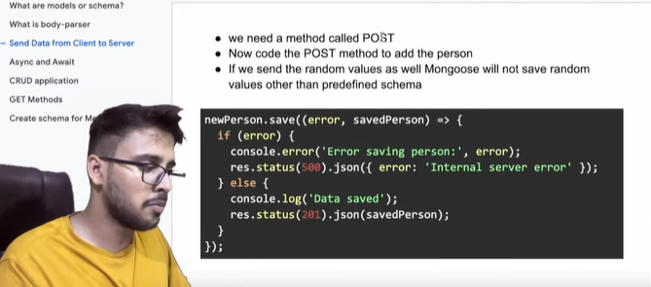

// *POST route to add a person*

app.post("/person", (req, res) => {

  const data = req.body; // *Assuming the request body contains the person*

});

The data coming from the client will be parsed by the body parser into the respective format and stored inside req.body. So, if we need to use that data, we will obviously take it from req.body. And that is what we are doing it here.

We have get the Person data which is stored in the data variable. Now we need to make a new document of a type Person.

const newPerson = new Person();

newPerson.name = data.name;

Person() is our model which have schema stored in it.

// *Create Person model*

const Person = mongoose.model("Person",personSchema);

module.exports = Person;

const newPerson = new Person();

  newPerson.name = data.name;

  newPerson.age = data.age;

  newPerson.mobile = data.email;

  newPerson.address = data.address;

But itna baar baar kon likhega so we make it easy and simple.

 const newPerson = new Person(data);

we have given data just instead of not giving the data and then storing the different details.

Now we need to save the database

// *Save the newPerson to the database*

  newPerson.save((error, person) => {

  })

Status Code

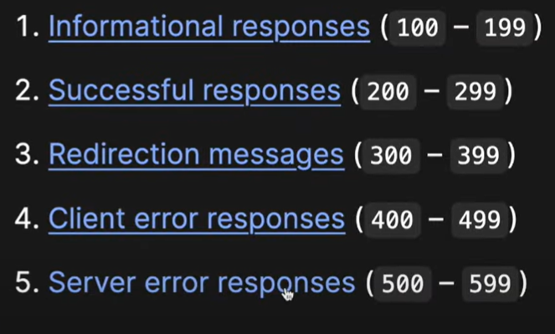

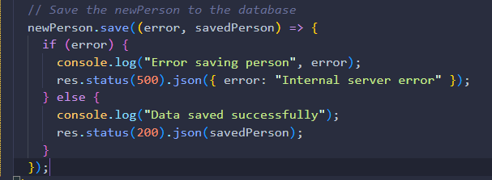

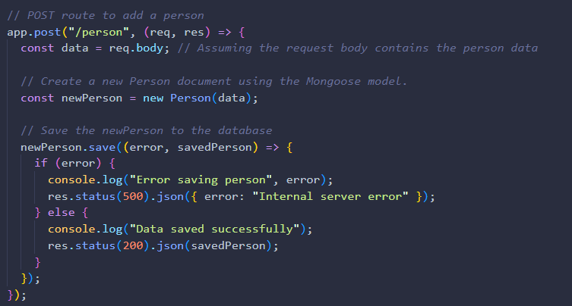When we give error message and we also send the response in which we send the status code and error or data in json format.

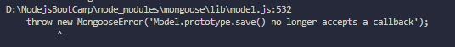When we save the data which give us a callback like above we will get the error :

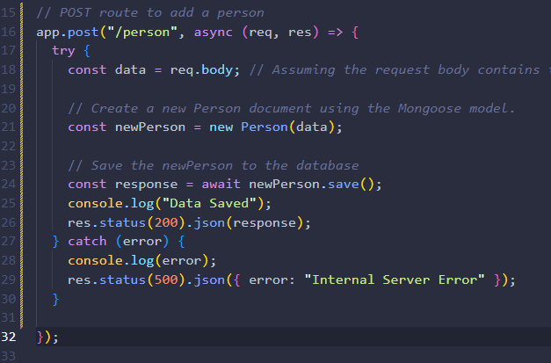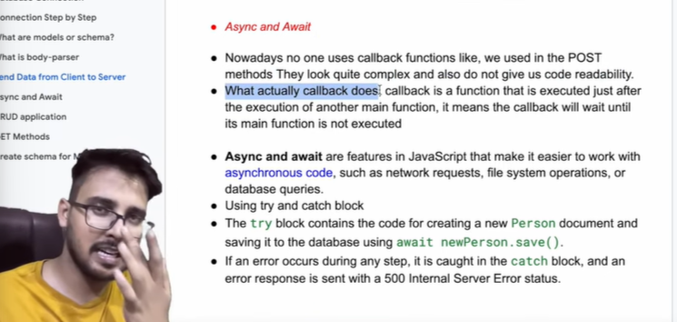

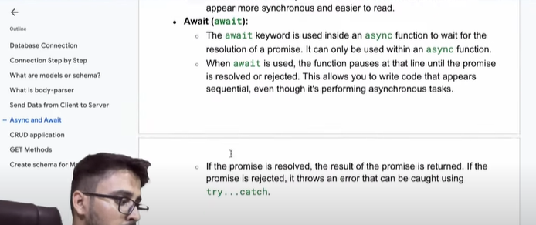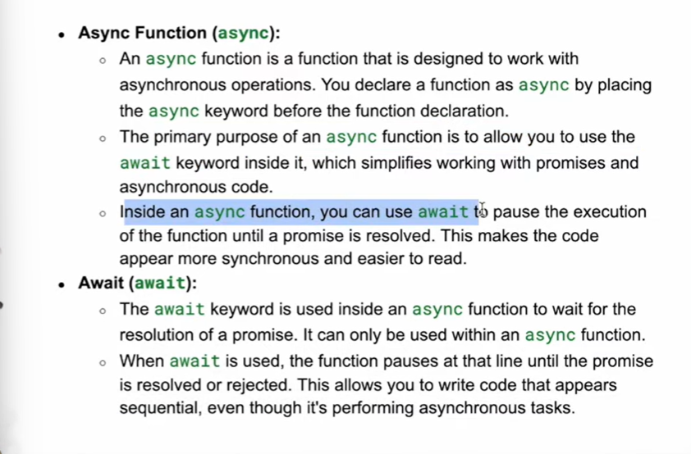This is the way you write.

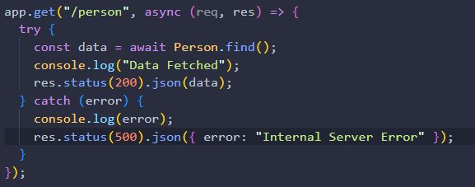

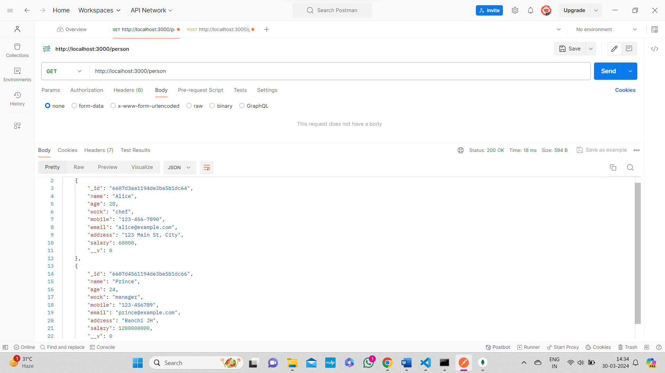Getting the Person data get method.

